 

Project Initialization and Planning Phase

|  |  |
| --- | --- |
| Date | 4th July 2024 |
| Team ID | 739804 |
| Project Name | Cost Prediction of Acquiring a Customer. |
| Maximum Marks | 3 Marks |

**Define Problem Statements (Customer Problem Statement Template):**

Predicting how much it costs to get a new customer ie. Customer Acquisition Cost(CAC) is really important for businesses trying to make their marketing and sales strategies work better. This involves looking at past data on how much money was spent on things like online ads, social media promotions, and other ways of reaching customers. By studying the different types of customers and how they behave, businesses can figure out which groups are the best to focus on to get new customers at the lowest cost. Using models that show where customers first hear about a business or how they interact with different ads helps decide where to spend money to get the most customers. Comparing how much it costs to get customers with what other businesses spend helps figure out how competitive a business is and find ways to spend money smarter. In the end, using predictions and trying out new ideas helps businesses plan their spending better, improve how they get new customers, and keep growing in a tough market.

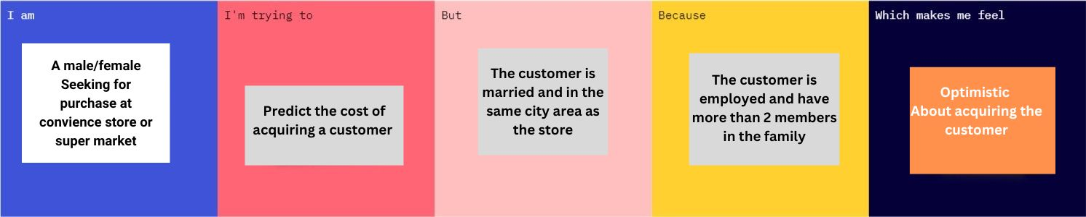

|  |  |  |  |  |  |
| --- | --- | --- | --- | --- | --- |
| **Problem Statement**  **(PS)** | **I am (Customer)** | **I’m trying to** | **But** | **Because** | **Which makes me feel** |
| PS-1 | A male/female  Seeking for purchase at convience store or super market | Predict the cost of acquiring a customer | The customer is married and in the same city area as the store | The customer is employed and have more than 2 members in the family | Optimistic  About acquiring the customer |